MA 374 (2021) Financial Engineering Lab Lab 06

**Name:** Udandarao Sai Sandeep

**Roll Number:** 180123063

**Dept.:** Mathematics and Computing

**Q1.**

Similar to the previous assignment, **company stock prices (10 from Sensex-BSE and 10 from Nifty-NSE)** ranging from **Jan 1, 2014 to Dec 31, 2018** was collected. (daily, weekly and monthly closing prices). Also, Nifty index values and Sensex index values (for the same range) was collected (from Yahoo Finance). Then, the **Stock Price vs Time** was plotted out.

|  |  |  |  |
| --- | --- | --- | --- |
| Stock Description | Daily | Weekly | Monthly |
| BSE Index |  |  |  |
| NSE Index |  |  |  |
| SBI |  |  |  |
| Titan |  |  |  |
| Reliance |  |  |  |
| ICICI |  |  |  |
| Axis |  |  |  |
| L&T |  |  |  |
| UltraTec |  |  |  |
| ITC |  |  |  |
| ONGC |  |  |  |
| Infosys |  |  |  |
| HDFC |  |  |  |
| TCS |  |  |  |
| Kotak |  |  |  |
| Airtel |  |  |  |
| Nestle |  |  |  |
| Housing |  |  |  |
| Maruti |  |  |  |
| Asian |  |  |  |
| HCL |  |  |  |
| Coal |  |  |  |

**Q2.**

Using the above collected data, the **returns Ri** have been calculated. And, also, corresponding values of µ and σ have ben also calculated. Normalized value of returns was then calculated. The superimposed graphs of **N** (0,1) and density histograms obtained are as follows:

For simplicity, only 4 companies have been shown.

|  |  |  |  |
| --- | --- | --- | --- |
| Stock Description | Daily | Weekly | Monthly |
| BSE Index |  |  |  |
| NSE Index |  |  |  |
| SBI |  |  |  |
| Titan |  |  |  |
| Reliance |  |  |  |
| ICICI |  |  |  |
| HDFC |  |  |  |
| TCS |  |  |  |
| Kotak |  |  |  |
| Airtel |  |  |  |
| Nestle |  |  |  |

It can be seen that **the Normal Distribution estimates with great similarity the Density plot of the stocks, and the resemblance strengthens with increase in data points.**

If we observe at the tails, we can see that the density plot jumps above the normal plots at some instances, and the normal ploy goes to zero. In real world scenarios, the stock prices are influences by many hard to predict factors, and hence don’t exactly follow the normal distribution. **Stock values might be over inflated in such scenarios, and hence can rise over the normal plots.**

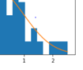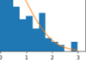

**Q3.**

In the logarithmic returns, we can see that the log normal returns suppress the ordinary returns. This effect amplifies when the percent return is high. Hence, we can see that tails are also somewhat suppressed. Here is a look at the log-normal returns density plots:

|  |  |  |  |
| --- | --- | --- | --- |
| Stock Description | Daily | Weekly | Monthly |
| BSE Index |  |  |  |
| NSE Index |  |  |  |
| SBI |  |  |  |
| Titan |  |  |  |
| Reliance |  |  |  |
| ICICI |  |  |  |
| HDFC |  |  |  |
| TCS |  |  |  |
| Kotak |  |  |  |
| Airtel |  |  |  |
| Nestle |  |  |  |

**Q4.**

For simulating the stock prices for the period of January 1, 2018 to December 31, 2018 by using the daily, monthly and weekly data for the period **January 1, 2014** to **December 31, 2017**.

We have used the jump diffusion model thinking that the ratio of asset price after and before a jump should follow the log-normal distribution **N (μ, σ2)**. Using first approach, (simulation of dates), stock prices have been simulated. **The actual vs estimated prices have been plotted out:**

|  |  |  |  |
| --- | --- | --- | --- |
| Stock Description | Daily | Weekly | Monthly |
| BSE Index |  |  |  |
| NSE Index |  |  |  |
| SBI |  |  |  |
| Titan |  |  |  |
| Reliance |  |  |  |
| ICICI |  |  |  |
| Axis |  |  |  |
| L&T |  |  |  |
| UltraTec |  |  |  |
| ITC |  |  |  |
| ONGC |  |  |  |
| Infosys |  |  |  |
| HDFC |  |  |  |
| TCS |  |  |  |
| Kotak |  |  |  |
| Airtel |  |  |  |
| Nestle |  |  |  |
| Housing |  |  |  |
| Maruti |  |  |  |
| Asian |  |  |  |
| HCL |  |  |  |
| Coal |  |  |  |

The mean, sigma and Company Name for the daily stock prices are as follows:

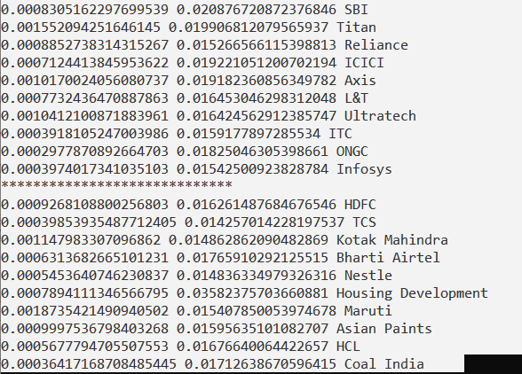

**Here, mean and sigma for Sensex and Nifty are as follows:**

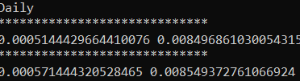

**Q5.**

They have been done in the above question.